**Course Methods Test 2 Year 12**

Student name: ________________ Teacher name: ________________

**Task type: Response**

**Reading time for this test : 5 mins**

**Working time allowed for this task: 40 mins**

**Number of questions: _____4______**

**Materials required:** Upto three calculators/classpads

Standard items: Pens (blue/black preferred), pencils (including coloured), sharpener, correction fluid/tape, eraser, ruler, highlighters

Special items: Drawing instruments, templates, notes on one unfolded sheet of   
A4 paper,

**Marks available: 42 marks**

**Task weighting: 13%**

**Formula sheet provided: no but formulae listed on next page.**

**Note: All part questions worth more than 2 marks require working to obtain full marks.**

Useful formulae

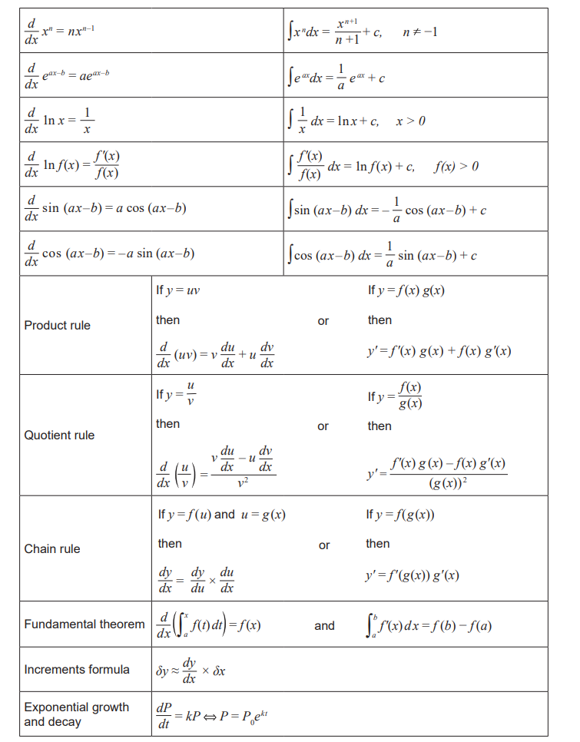Q1 (2, 3, 3 & 2 = 10 marks)

Consider the functions  and the table of values below.

|  |  |  |  |  |  |
| --- | --- | --- | --- | --- | --- |
| Function | X=1 | X=2 | X=3 | X=4 | X=5 |
|  | 5 | -7 | 9 | 13 | -22 |
|  | 8 | -10 | 12 | 18 | 3 |
|  | -3 | 2 | 5 | -7 | 4 |
|  | -6 | 10 | 8 | -9 | -2 |

Determine the following showing full working.

1. 
2. 
3. 
4. 

Q2 (1, 2, 3, 2 & 3 = 11 marks)

Consider a group of kangaroos living in an isolated habitat such that the number of kangaroos,  at time  years ( at the start of 2012), is given by .

1. Determine the number of kangaroos at the start of 2012.
2. Determine the increase in kangaroos over the first 5 years.
3. Determine to the nearest month when the population first exceeds 100000.
4. Determine the rate of growth at the start of 2024.

After 10 years the number of kangaroos starts to decline according the formula  where  are constants.

1. Determine if after 3 years after the decline of the kangaroos, the population is back to 64000.

Q3 (2, 2, 2, 2 & 4 = 12 marks)

An oscillating mass has a velocity,  given by  , .

The velocity is measured in metres/second with the time,  in seconds.

Find below a graph of the velocity.

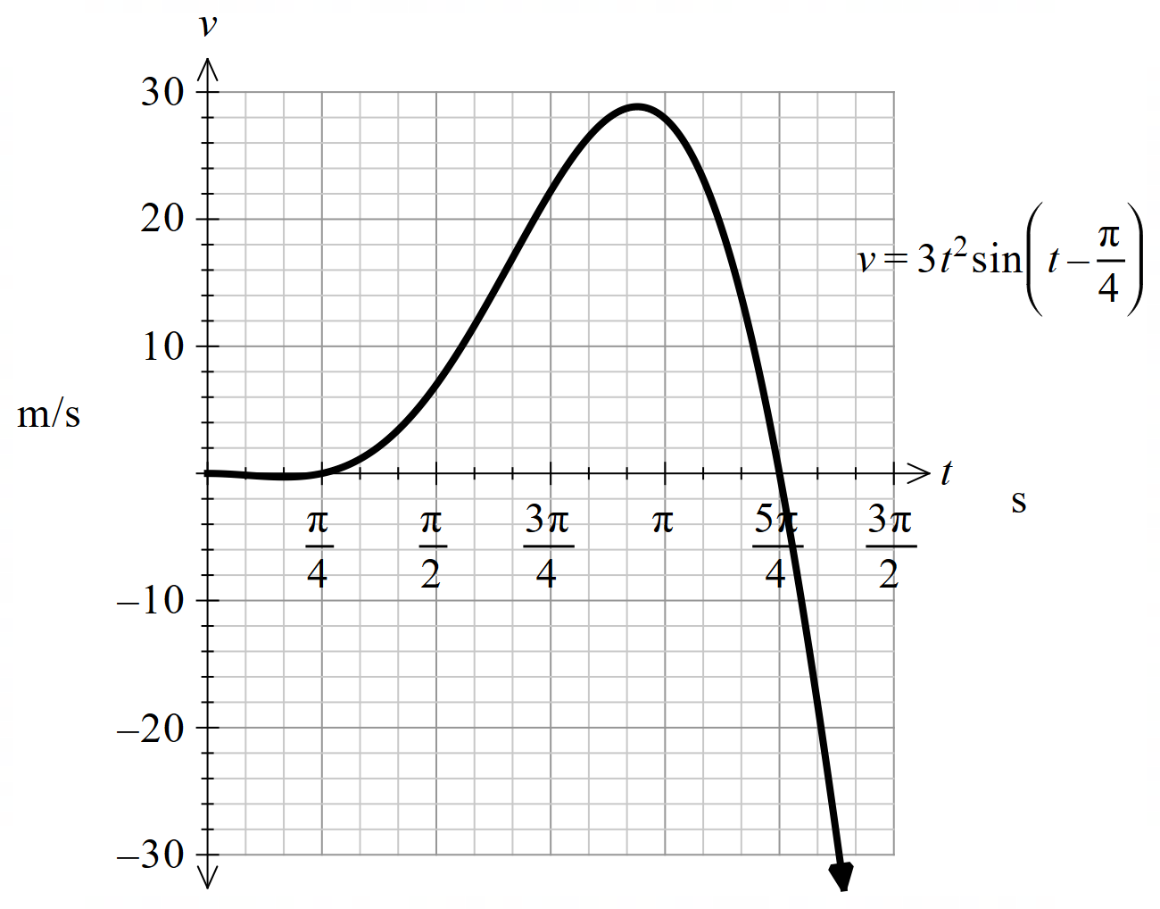

x-π/4+6*x*sin(x-π/4)=0|0≤x≤2*π

x*sin(x-π/4)=0|0≤x≤2*π

1. Determine the first two exact times that the mass changes direction, .
2. Shade on the diagram above the signed area that is represented by the integral

 .

1. What does the integral represent for the mass?

Q3 cont-

1. Determine the first time after seconds that the acceleration is zero . **(2 marks)**
2. The displacement of the mass is given by  metres, where  are constants. Determine the values of .

Q4 (2, 3 & 4 = 9 marks)

A team of surveyors mapped the depth of the ocean in a region populated by turtles. They discovered a large trench extending below the otherwise flat seabed as shown in the diagram below.

The displacement, in kilometres, from sea level to the ocean floor is given by



Note:  both in Kilometres

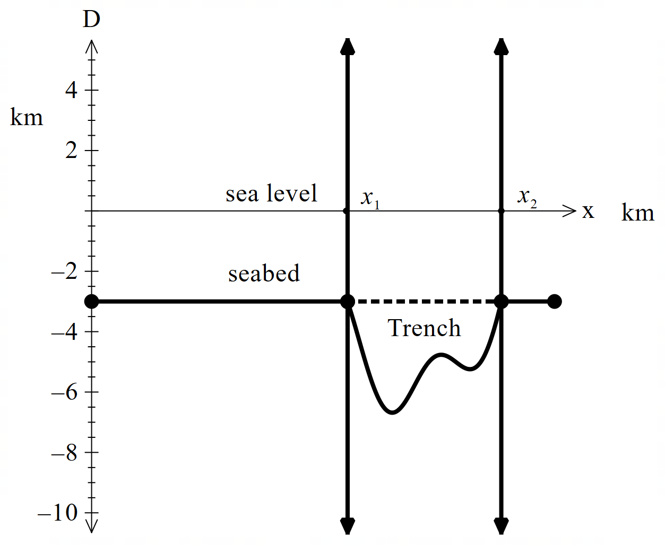

1. Determine the values of  to two decimal places.

The trench cross-sectional area is defined by the following region:



1. Using calculus, determine the cross-sectional area of the trench to one decimal place.

Q4 cont-

1. Using calculus, determine the maximum distance of the trench below sea level.

Working out space

Working out space

Working out space

Working out space